**Outputs, Inputs and Variables Worksheet – Year 8 Computer Studies**

**INPUT Displays a message and waits for a user input!**

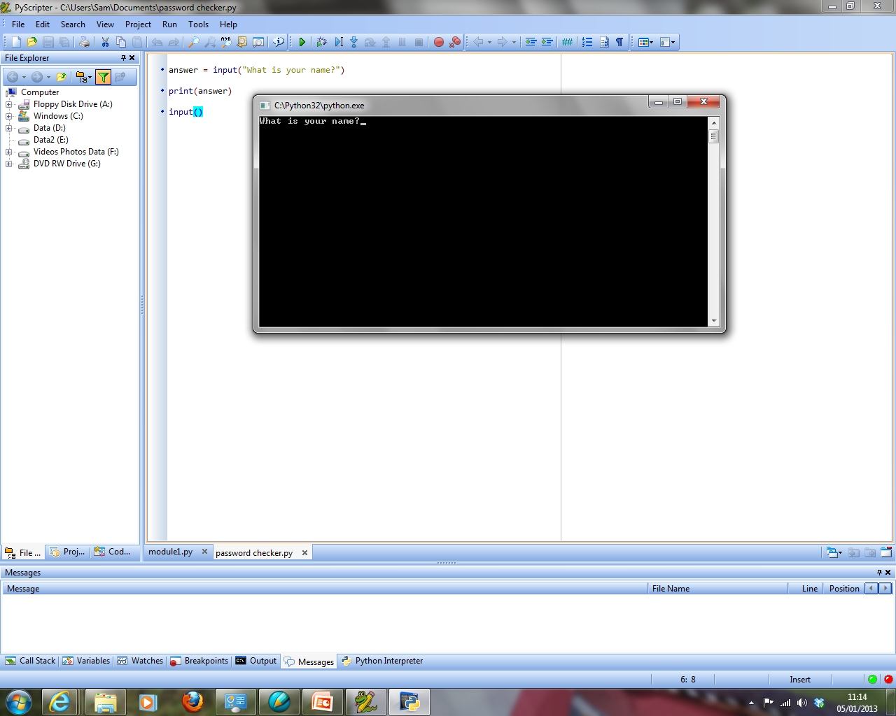**Things to remember:**

**PRINT just displays a message!**

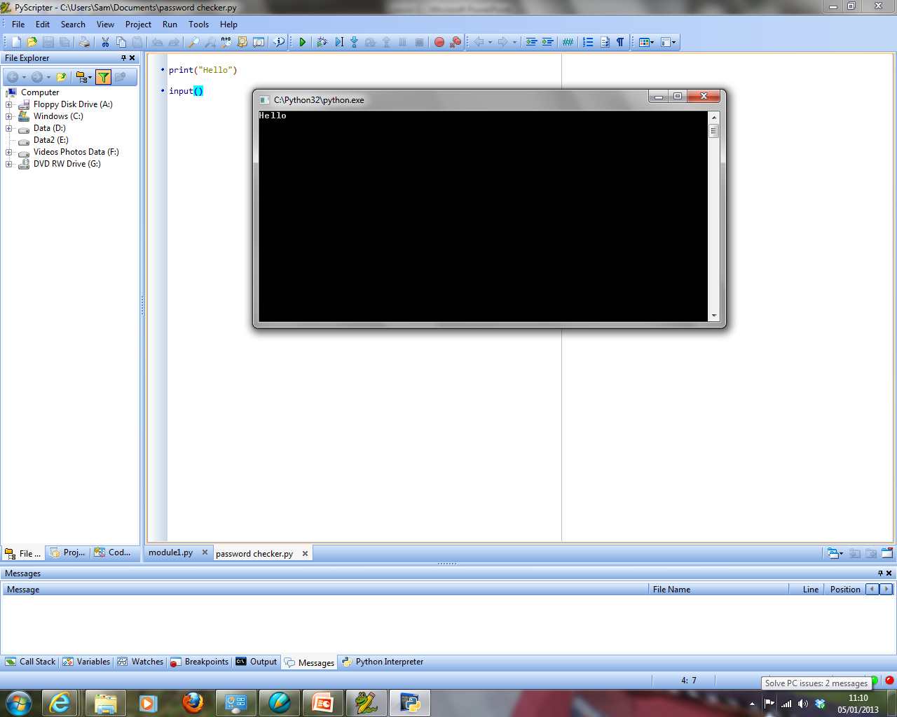



**So, it needs to equal a variable if we want to store what the user types in…**

See below for examples of the print statement and input statements written in Python:

**EXAMPLE 1 – Displaying / Printing to the Screen**



The print statement will display whatever is written in its brackets.

**Important**: If we want text (a datatype called a string) to display, it must be placed inside quotation marks.

**EXAMPLE 2 – Getting a User Input, Storing it and then Printing it to the Screen**

The input statement will display whatever is written in its brackets and then also wait for a user input. Notice here we are printing the contents of the variable (answer) and instead of a message – notice the lack of quotes!!

**Important**: If we want to store what the user types into the computer it needs to be stored. We do this by assigning a variable to the input statement (e.g.: **answer =** )



**Programming Activities**

The **examples** (shown above) will help with these tasks:

1. Create a program which prints your name to the screen

.--.

.----' '--.

'-()-------()-'

1. Create a program which prints a message of your choice to the screen
2. Create a program to output this car to the screen
3. Create a program to output a design of your choice to the screen
4. Write a program that will allow the user to input their name and age and then output the name and age that have been entered on the screen.
5. Write a program that will allow the user to input their name and then output the name joined with a greeting in the format: “Hello Sam”.
6. Create a program of your own, using the skills you have learned. Maybe a conversation!